ShopBridge API Documentation

1. Database Table Script

CREATE TABLE Products (

Id int IDENTITY(1,1) PRIMARY KEY,

Name nvarchar(100) NOT NULL,

Description nvarchar(500) NOT NULL,

Price decimal NOT NULL,

IsActive tinyint,

CreatedBy nvarchar(100),

CreatedOn DateTime,

UpdatedBy nvarchar(100),

UpdatedOn DateTime

);

1. Post Data

url - https://localhost:44331/api/product

Request Body

{

  "Id":"0",

  "Name": "Test Prod",

  "Description": "Prod2 Desc",

  "Price": 6.0,

  "IsActive": **true**,

  "CreatedBy": "Admin"

}

Response

{

    "Message": "Success",

    "Data": 1,

    "Status": "S"

}

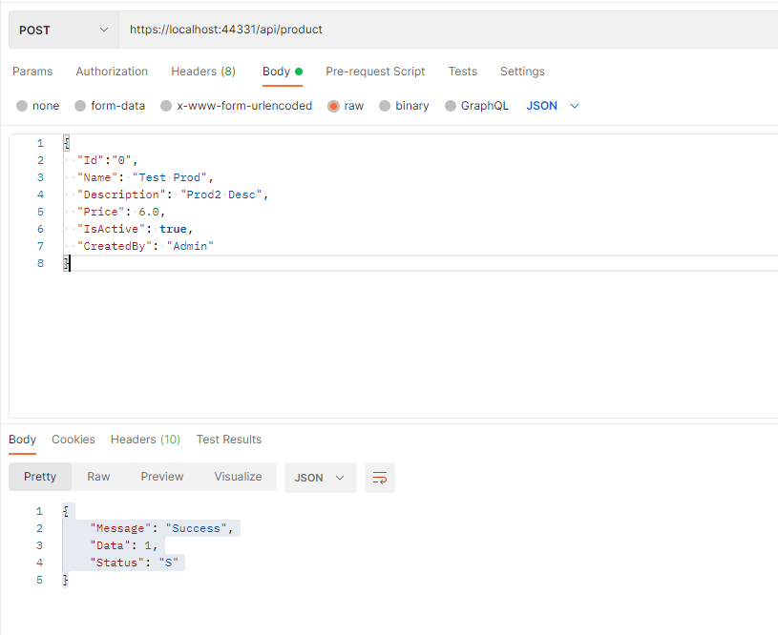

1. Put Data

url - <https://localhost:44331/api/product>

body

{

  "Id":"3",

  "Name": "Prod2",

  "Description": "Prod2 Desc",

  "Price": 6.0,

  "IsActive": **true**,

  "CreatedBy": "Admin",

  "UpdatedBy": "Admin"

}

Response

{

    "Message": "Success",

    "Data": 1,

    "Status": "S"

}

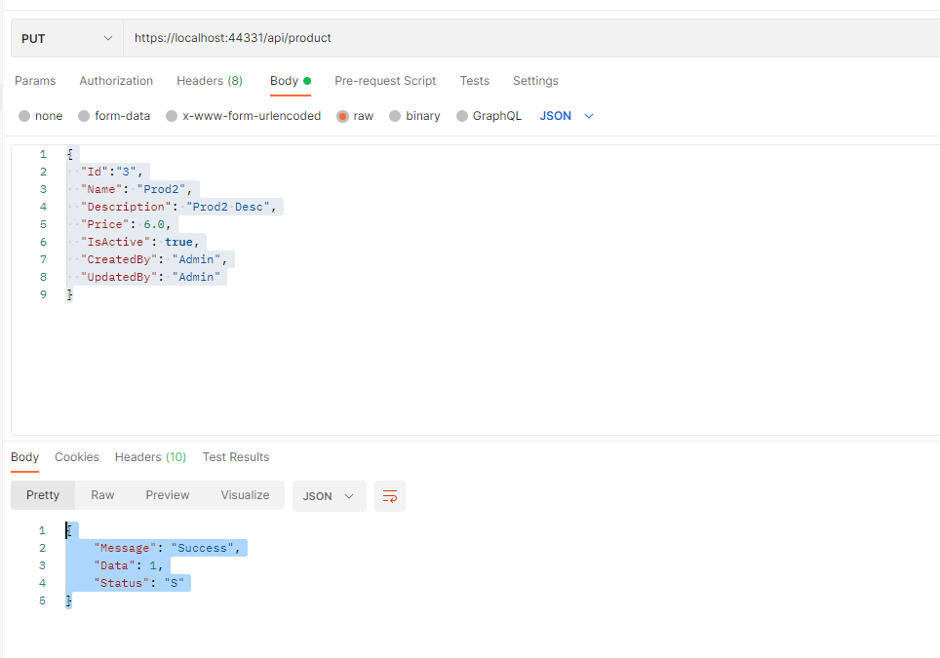

1. Get All Products

url - <https://localhost:44331/api/product>

body – NA

Response-

{

    "Message": "Success",

    "Data": [

        {

            "Id": 1,

            "Name": "Prod1",

            "Description": "Prod Desc",

            "Price": 4.0,

            "IsActive": **true**,

            "CreatedBy": "Admin",

            "CreatedOn": "2022-06-07T23:05:53.283",

            "UpdatedBy": "Admin",

            "UpdatedOn": "2022-06-07T23:05:53.283"

        },

        {

            "Id": 3,

            "Name": "Prod2",

            "Description": "Prod2 Desc",

            "Price": 6.0,

            "IsActive": **true**,

            "CreatedBy": "Admin",

            "CreatedOn": "2022-06-07T23:13:36.093",

            "UpdatedBy": "Admin",

            "UpdatedOn": "2022-06-07T23:14:20.4"

        }

    ],

    "Status": "S"

}

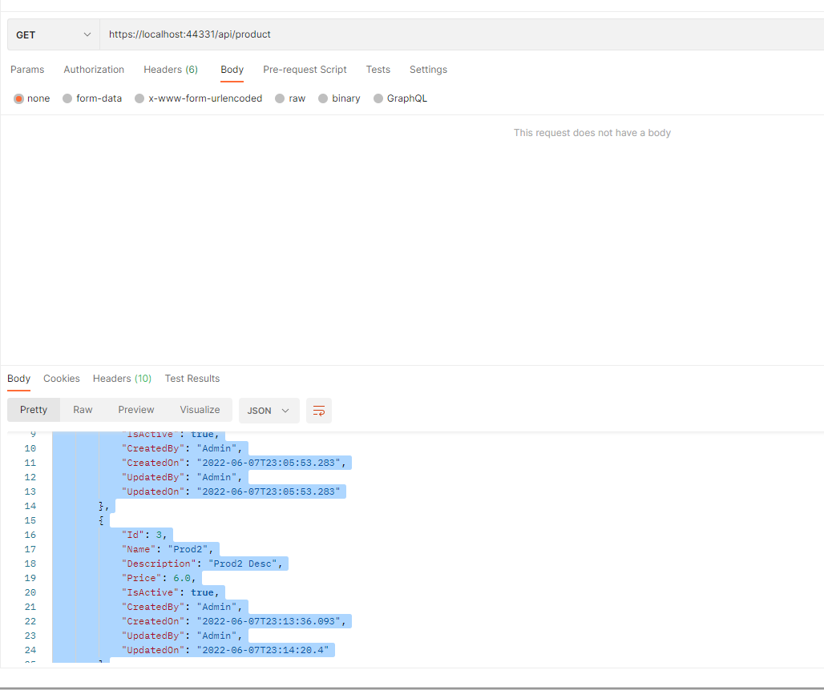

1. Delete Product

url - <https://localhost:44331/api/product/4>

Body-NA

Reponse:

{

    "Message": "Success",

    "Data": 1,

    "Status": "S"

}

